# A4-1

1. We choose P=12 different initial points (-10, $±$ 2), (-6, $±$ 2), (-2, $±$ 2), (2, $±$ 2), (6, $±2$), (10, $±2)$. The figures which contains the paths is showing as Figure 1(a). The figure of ${(log ||x^{k}-x^{*}||)}_{k}$ can be seen in Figure 1(b). As we can see from the figure, the convergence type is quadratic convergence.

(a) Paths of Newton method with different points (b) $log ||x^{k}-x^{*}||$ VS number of iteration

**Figure 1 The plot of iteration process**

By comparing the performance of the Newton method and gradient method tested in A3.3, we can derive Table 1. From the table, we can see that the Newton method is much better than the gradient method. The Newton method needs smallest iterations and time.

|  |  |  |  |
| --- | --- | --- | --- |
| Method | tolerance | iteration | Time(s) |
| GM with backtracking | $${10}^{-8}$$ | 2793 | 1.613 |
| GM with diminishing | $${10}^{-8}$$ | 85266 | 8.516 |
| GM with exact line search | $${10}^{-8}$$ | 695 | 1.007 |
| Newton method | $${10}^{-8}$$ | 9 | 0.035 |

**Table 1 Performance of different methods**

The python code is as follow

|  |
| --- |
| **import** numpy **as** np **import** matplotlib.pyplot **as** plt **import** time  **def** f1(x):  x = x.reshape(x.size)  **return** 3 + x[0] + ((1 - x[1]) * x[1] - 2) * x[1] **def** f2(x):  x = x.reshape(x.size)  **return** 3 + x[0] + (x[1] - 3) * x[1] **def** f(x):  x = x.reshape(x.size)  **return** f1(x) * f1(x) + f2(x) *f2(x) **def** df(x):  x = x.reshape(x.size)  grad = np.zeros(2).reshape(2,1)  grad[0] = 2 * f1(x) + 2 * f2(x)  grad[1] = 2 * f1(x) * (2*x[1] - 3*(x[1]**2) - 2) + 2 * f2(x) * (2*x[1] - 3)  **return** grad **def** Hessian(x):  x = x.reshape(x.size)  hessian = np.zeros((2,2))  hessian[0][0] = 4  hessian[0][1] = 8*x[1]-6*(x[1]**2)-10  hessian[1][0] = 8*x[1]-6*(x[1]**2)-10  hessian[1][1] = 2*f1(x)*(-6*x[1]+2) + 2*(2*x[1]-3*(x[1]**2)-2)**2+4*f2(x)+2*(2*x[1]-3)**2  **return** hessian **def** norm(x):  x = x.reshape(x.size)  **return** np.sqrt(x[0]**2 + x[1]**2)  color_list = [**'red'**,**'blue'**, **'green'**, **'orange'**,**'cyan'**, **'purple'**, **'black'**,**'yellow'**, **'teal'**,  **'coral'**,**'brown'**, **'darkred'**] Number_iterations = []  **def** plot_contour():  X = np.arange(-17.5,12.5,0.05)  Y = np.arange(-3, 3, 0.05)  X,Y = np.meshgrid(X,Y)  Z = np.zeros((X.shape[0], X.shape[1]))  **for** i **in** range(X.shape[0]):  **for** j **in** range(X.shape[1]):  x = []  x.append(X[i][j])  x.append(Y[i][j])  x = np.array(x)  Z[i][j] = f(x)  plt.contourf(X, Y, Z, 30, alpha=0.3, cmap=plt.cm.hot)  plt.contour(X, Y, Z, 30, colors=**'grey'**)   **def** plot_line(xk_list, subfig_num):  plt.figure(1)  x = []  y = []  **for** i **in** range(xk_list.shape[0]):  x.append(xk_list[i][0][0])  y.append(xk_list[i][1][0])  plt.plot(x,y, color = color_list[subfig_num-1], linewidth=1.5)  plt.scatter(x, y, s=3, color=**'black'**)  **def** plot_convergence(y, subfig_num):  plt.figure(2, figsize=(8,10))  n = y.size  x = np.arange(n)  y = np.log(y)  plt.plot(x, y, color = color_list[subfig_num-1], linewidth=2)  plt.xlabel(**'number of iteration'**)  plt.ylabel(**'$log||(x^k-x^*)||$'**)  plt.tight_layout()  **def** check_dir(dk_tocheck, xk, gradient, hessian, beta1, beta2):  dk_norm = norm(dk_tocheck)  factor1 = np.dot(gradient.T, dk_tocheck)[0][0] < 0  facotr2 = -(np.dot(gradient.T, dk_tocheck)[0][0]) >= beta1 * np.min([1, dk_norm**beta2]) * dk_norm**2  **if** factor1 == **True and** facotr2 == **True**:  **return True  else**:  **return False def** Global_Newton(initial, subfig_num):  *#paramaters* s = 1  sigma = 0.5  gamma = 0.1  beta1 = 1e-6  beta2 = 0.1  tol = 1e-8  xk_list = []  xk_xstar_list = []    xk = initial  num_iteration = 0  xk_list.append(xk)     gradient = df(xk)  **while** norm(gradient) > tol:  *# deteriminate the direction* hessian = Hessian(xk)  dk_tocheck = np.linalg.solve(hessian, -gradient)  good_dir = check_dir(dk_tocheck, xk, gradient, hessian, beta1, beta2)  **if**(good_dir == **False**):  dk = -gradient  **else**:  dk = dk_tocheck     alphak = s  **while True**:  **if** f(xk + alphak*dk) - f(xk) <= gamma * alphak * (np.dot(gradient.T, dk)[0][0]):  **break** alphak = alphak * sigma  xk = xk + alphak * dk  xk_list.append(xk)    gradient = df(xk)  num_iteration = num_iteration + 1    Number_iterations.append(num_iteration)    plt.figure(1)  plt.scatter(xk_list[-1][0], xk_list[-1][1], s=60, marker=**'*'**,   facecolors =**'none'**, edgecolor= color_list[subfig_num-1])  xk_list = np.array(xk_list)  plot_line(xk_list, subfig_num)   xstar_x1 = xk_list[-1][0][0]  xstar_x2 = xk_list[-1][1][0]  xstar = np.array([round(xstar_x1), xstar_x2]).reshape(2, 1)  **for** i **in** range(xk_list.shape[0]):  xk_xstar_list.append(norm(xk_list[i] - xstar))  xk_xstar_list = np.array(xk_xstar_list)  plot_convergence(xk_xstar_list, subfig_num) *# main begin* x1 = np.arange(-10, 11, 4) x2 = np.arange(-2, 3, 4)  plt.figure(1, figsize=(10, 5)) plot_contour() subfig_num = 1  time_list = [] **for** i **in** range(6):  **for** j **in** range(2):  initial = np.zeros(2).reshape(2,1)  initial[0][0] = x1[i]  initial[1][0] = x2[j]  plt.figure(1)  plt.scatter(initial[0], initial[1], s=40, marker=**'s'**,   facecolors =**'none'**, edgecolor= color_list[subfig_num-1])    start = time.time()  Global_Newton(initial, subfig_num)  end = time.time()    time_list.append(end - start)  subfig_num = subfig_num + 1  plt.figure(1) plt.xlabel(**'x1'**) plt.ylabel(**'x2'**) plt.xlim(-17, 12) plt.ylim(-2.5, 2.5) plt.savefig(**'A4_1_a'**, dpi=700)   plt.figure(2) plt.savefig(**'A4_1_a_convergence'**, dpi=700)   print() print(**'Number of iterations from different initial points:'**, Number_iterations) print(**'Average number of iterations from different initial points:'**,   sum(Number_iterations)/len(Number_iterations))  print(**'Calculating time from different initial points:'**, time_list) print(**'Average calculating time from different initial points:'**,   sum(time_list)/len(time_list))    **""" x1, x2 = symbols('x1 x2', real=True) ans1 = diff(2*(3 + x1 + ((1 - x2) * x2 - 2) * x2) + 2*(3 + x1 + (x2 - 3) * x2), x1).subs({x1:-7, x2:1}) ans2 = diff(2*(3 + x1 + ((1 - x2) * x2 - 2) * x2) + 2*(3 + x1 + (x2 - 3) * x2), x2).subs({x1:-7, x2:1}) ans3 = diff(2*(3 + x1 + ((1 - x2) * x2 - 2) * x2)*(2*x2-3*x2**2-2) + 2*(3 + x1 + (x2 - 3) * x2)*(2*x2-3), x1).subs({x1:-7, x2:1}) ans4 = diff(2*(3 + x1 + ((1 - x2) * x2 - 2) * x2)*(2*x2-3*x2**2-2) + 2*(3 + x1 + (x2 - 3) * x2)*(2*x2-3), x2).subs({x1:-7, x2:1}) print(ans1) print(ans2) print(ans3) print(ans4) """** |

|  |  |  |  |  |  |
| --- | --- | --- | --- | --- | --- |
| Method | tolerance | iteration | Time(s) | Always use Newton direction | αk = 1 |
| GM with backtracking | $${10}^{-1}$$ | 54 | 0.05 |  | False |
| $${10}^{-3}$$ | 5231 | 1.108 | False |
| $${10}^{-5}$$ | 1096 | 2.303 | False |
| Newton Method | $${10}^{-1}$$ | 19 | 0.166 | True | False |
| $${10}^{-3}$$ | 20 | 0.075 | True | False |
| $${10}^{-5}$$ | 21 | 0.08 | True | False |

*b)* By comparing the performance of the Newton method and gradient method with backtracking, we can derive Table 2. From the table, we can see that the Newton method is much better than the gradient method with backtracking. The Newton method always utilize the Newton direction. Newton method and gradient method both do not always use full step sizes αk = 1. The figures which contains the paths is showing as Figure 2. The figure of ${(log ||x^{k}-x^{*}||)}_{k}$ can be seen in Figure 3(a). By zooming in Figure 3(a), we get Figure 3(b). as we can see from the figure, the gradient method is linear convergence, and the Newton method is quadratic convergence.

**Table 2 performance of different methods on Rosenbrock function**

**Figure 2 Path of Newton method and gradient mothod with backtracking**

**Figure 3 The plot of iteration of process**

The python code to solve this problem is showing below.

|  |
| --- |
| **import** numpy **as** np **import** matplotlib.pyplot **as** plt **import** time  **def** f(x): *# Rosenbrock function* x = x.reshape(x.size)  **return** 100*(x[1] - x[0]**2)**2 + (1-x[0])**2 **def** df(x):  x = x.reshape(x.size)  grad = np.zeros(2).reshape(2,1)  grad[0] = -400 * x[0] * (x[1] - x[0]**2) + 2 * x[0] -2  grad[1] = 200 * (x[1] - x[0]**2)  **return** grad **def** Hessian(x):  x = x.reshape(x.size)  hessian = np.zeros((2,2))  hessian[0][0] = -400 * (x[1] - 3*x[0]**2) + 2  hessian[0][1] = -400 * x[0]  hessian[1][0] = -400 * x[0]  hessian[1][1] = 200  **return** hessian **def** norm(x):  x = x.reshape(x.size)  **return** np.sqrt(x[0]**2 + x[1]**2)  color_list = [**'red'**,**'blue'**, **'green'**, **'orange'**,**'cyan'**, **'purple'**, **'black'**,**'yellow'**, **'teal'**,  **'coral'**,**'brown'**, **'darkred'**] label_list = [**'Newton method'**, **'Gradient method with backtracking'**] tol_list = [1e-1, 1e-3, 1e-5]   **def** plot_contour():  X = np.arange(-1.51,1.6,0.05)  Y = np.arange(-1.55, 2.55, 0.05)  X,Y = np.meshgrid(X,Y)  Z = np.zeros((X.shape[0], X.shape[1]))  **for** i **in** range(X.shape[0]):  **for** j **in** range(X.shape[1]):  x = []  x.append(X[i][j])  x.append(Y[i][j])  x = np.array(x)  Z[i][j] = f(x)  plt.contourf(X, Y, Z, 20, alpha=0.3, cmap=plt.cm.hot)  plt.contour(X, Y, Z, 20, colors=**'grey'**)   **def** plot_line(xk_list, subfig_num):  plt.figure(1)  x = []  y = []  **for** i **in** range(xk_list.shape[0]):  x.append(xk_list[i][0][0])  y.append(xk_list[i][1][0])  plt.plot(x,y, color = color_list[subfig_num], linewidth=1.5, label=label_list[subfig_num])  plt.scatter(x, y, s=3, color=**'black'**)  **def** plot_convergence(y, method, subfig_num, tol_index):  tol_index = tol_index + 1  plt.figure(2, figsize=(8,10))  plt.subplot(3,1,tol_index)  n = y.size  x = np.arange(n)  y = np.log(y)  plt.plot(x, y, label = method, color = color_list[subfig_num], linewidth=2)  plt.legend()  plt.xlabel(**'number of iteration (tol={})'**.format(str(tol_list[tol_index-1])))  plt.ylabel(**'$log||(x^k-x^*)||$'**)  plt.tight_layout()  *#plt.xlim(0,100)* **def** check_dir(dk_tocheck, xk, gradient, hessian, beta1, beta2):  dk_norm = norm(dk_tocheck)  factor1 = np.dot(gradient.T, dk_tocheck)[0][0] < 0  facotr2 = -(np.dot(gradient.T, dk_tocheck)[0][0]) >= beta1 * np.min([1, dk_norm**beta2]) * dk_norm**2  **if** factor1 == **True and** facotr2 == **True**:  **return True  else**:  **return False def** Global_Newton(initial, subfig_num, tol, tol_index):  *#paramaters* xstar = np.array([1, 1]).reshape(2, 1)  s = 1  sigma = 0.5  gamma = 1e-4  beta1 = 1e-6  beta2 = 0.1  xk_list = []  xk_xstar_list = []  alphak_list_Newton = []  Always_Use_Newton_Dir = **True** xk = initial  num_iteration = 0  xk_list.append(xk)  xk_xstar_list.append((norm(xk-xstar)))    gradient = df(xk)  **while** norm(gradient) > tol:  *# deteriminate the direction* hessian = Hessian(xk)  dk_tocheck = np.linalg.solve(hessian, -gradient)  good_dir = check_dir(dk_tocheck, xk, gradient, hessian, beta1, beta2)  **if**(good_dir == **False**):  dk = -gradient  Always_Use_Newton_Dir = **False  else**:  dk = dk_tocheck     alphak = s  alphak_list_Newton.append(alphak)    **while True**:  **if** f(xk + alphak*dk) - f(xk) <= gamma * alphak * (np.dot(gradient.T, dk)[0][0]):  **break** alphak = alphak * sigma  alphak_list_Newton.append(alphak)  xk = xk + alphak * dk  xk_list.append(xk)  xk_xstar_list.append((norm(xk-xstar)))    gradient = df(xk)  num_iteration = num_iteration + 1    print(**'tolerance:'**, tol)  print(**'Newton_num_iteration:'**, num_iteration)  print(**'Always_Use_Newton_Dir:'**, Always_Use_Newton_Dir)  print(**'alpha_k of Newton method'**, alphak_list_Newton)  print()    method = **'Newton method'** xk_xstar_list = np.array(xk_xstar_list)  plot_convergence(xk_xstar_list, method, subfig_num, tol_index)    **if** tol == 1e-5:  plt.figure(1)  plt.scatter(xk_list[-1][0], xk_list[-1][1], s=60, marker=**'*'**,   facecolors =**'none'**, edgecolor= **'r'**)  xk_list = np.array(xk_list)  plot_line(xk_list, subfig_num)  **def** gradient_method(initial, subfig_num, tol, tol_index):  xstar = np.array([1, 1]).reshape(2, 1)  s = 1  sigma = 0.5  gamma = 1e-4  xk_list = []  xk_xstar_list = []  alphak_list_GM = []     xk = initial  gradient = df(xk)  num_iteration = 0  xk_list.append(xk)  xk_xstar_list.append((norm(xk-xstar)))    **while** norm(gradient) > tol:  alphak = s  alphak_list_GM.append(alphak)    dk = -df(xk)  **while True**:  **if** f(xk + alphak*dk) - f(xk) <= gamma * alphak * (np.dot(df(xk).T, dk)[0][0]):  **break** alphak = alphak * sigma    alphak_list_GM.append(alphak)  xk = xk + alphak * dk  xk_list.append(xk)  xk_xstar_list.append((norm(xk-xstar)))    gradient = df(xk)  num_iteration = num_iteration + 1    print(**'tolerance:'**, tol)  print(**'Gradient_mothd_num_iteration:'**, num_iteration)  print(**'alpha_k of GM method'**, alphak_list_GM)  print()    method = **'Gradient method'** xk_xstar_list = np.array(xk_xstar_list)  plot_convergence(xk_xstar_list, method, subfig_num, tol_index)    **if** tol == 1e-5:  plt.figure(1)  plt.scatter(xk_list[-1][0], xk_list[-1][1], s=60, marker=**'*'**,   facecolors =**'none'**, edgecolor= **'r'**)  xk_list = np.array(xk_list)  plot_line(xk_list, subfig_num)   *# main begin* x1 = np.arange(-10, 11, 4) x2 = np.arange(-2, 3, 4)  plt.figure(1, figsize=(10, 5)) plot_contour()  initial = np.array([[-1.2], [1]]) plt.figure(1) plt.scatter(initial[0], initial[1], s=40, marker=**'s'**,   facecolors =**'none'**, edgecolor= **'b'**)  print(**'----------Newton Method----------'**) **for** index, tol **in** enumerate(tol_list):    start = time.time()  Global_Newton(initial, 0, tol, index)  end = time.time()    print(**'time:'**, end - start)  print()   print(**'----------Gradient Method----------'**) **for** index, tol **in** enumerate(tol_list):    start = time.time()  gradient_method(initial, 1, tol, index)  end = time.time()    print(**'time:'**, end - start)  print()  plt.figure(1) plt.xlabel(**'x1'**) plt.ylabel(**'x2'**) plt.xlim(-1.5, 1.5) plt.ylim(-1, 2) plt.legend() *# plt.show()* plt.savefig(**'A4_1_b'**, dpi=700)  plt.figure(2) plt.savefig(**'convergence'**, dpi=700) |

A 4-2

a) The code is as follows

|  |
| --- |
| **import** matplotlib.pyplot **as** plt **import** time  **def** norm(x):  x = x.reshape(x.size)  **return** np.sqrt(np.sum(x**2))  **def** norm_square(x):  x = x.reshape(x.size)  **return** np.sum(x**2)  **def** huber(t):  **if** np.abs(t) <= delta:  **return** (t**2) / (2*delta)  **else**:  **return** np.abs(t) - delta/2  **def** d_huber(t):  **if** np.abs(t) <= delta:  **return** t/delta  **else**:  **return** t/np.abs(t)  **def** log_fun(t):  **return** np.log(1 + t**2/v)   **def** d_log_fun(t):  **return** (1/(1+t**2/v)) * (2*t/v)   **def** phi_1(x):  **return** norm_square(x)  **def** d_phi_1(x):  grad = 2*x  **return** grad  **def** phi_2(x):  x = x.reshape(x.size)  Sum = 0  **for** xi **in** x:  Sum = Sum + huber(xi)  **return** Sum  **def** d_phi_2(x):  x = x.reshape(x.size)  grad = np.zeros((x.size,1))  **for** i **in** range(grad.size):  grad[i] = d_huber(x[i])  **return** grad    **def** phi_3(x):  x = x.reshape(x.size)  Sum = 0  **for** xi **in** x:  Sum = Sum + log_fun(xi)  **return** Sum  **def** d_phi_3(x):  x = x.reshape(x.size)  grad = np.zeros((x.size,1))  **for** i **in** range(grad.size):  grad[i] = d_log_fun(x[i])  **return** grad  color_list = [**'blue'**, **'green'**, **'red'**, **'cyan'**, **'purple'**, **'yellow'**, **'orange'**, **'teal'**,  **'coral'**, **'darkred'**, **'brown'**, **'black'**] **def** plot_convergence(y, method, subfig_num, tol):  plt.figure(1)  plt.subplot(2,1,subfig_num)  n = y.size  x = np.arange(n)  y = np.log(y)  plt.plot(x, y, label = method, color = color_list[subfig_num], linewidth=2)  plt.legend()  plt.xlabel(**'number of iteration (tol={})'**.format(tol))  plt.ylabel(**'$log||gradient||$'**)  plt.tight_layout()  **def** plt_compare_and_sparse(x_solution, subfig_num):  plt.figure(subfig_num+1, figsize=(8,20))  plt.subplot(2,1,1)  plt.scatter(x_solution, x_star, color=color_list[0], s=2)  xmin = x_solution.min()  xmax = x_solution.max()    plt.plot([x_star.min(), x_star.max()], [x_star.min(), x_star.max()], **'--'**, color=**'red'**, linewidth=1, label=**'diagonal line'**)  plt.xlim(xmin-0.02, xmax+0.01)  plt.xlabel(**'Solution'**)  plt.ylabel(**'$x^*$'**)  plt.legend()    plt.subplot(2,1,2)  n = x_solution.size  plt.plot([0,n], [0,0], **'--'**, color=**'red'**, linewidth=1)  plt.scatter(np.arange(n)+1, x_solution, color=color_list[1], s=2)  plt.xlabel(**'$i$ (the $i^{th}$ unit of solution)'**)  plt.ylabel(**'The value of $i^{th}$ unit in solution'**)   plt.tight_layout()  plt.savefig(**'compare_f'** +str(subfig_num), dpi=700)     **def** f1(x):  **return** 1/2 * norm_square(np.dot(A,x) - b) + mu * phi_1(x)  **def** f2(x):  **return** 1/2 * norm_square(np.dot(A,x) - b) + mu * phi_2(x)  **def** f3(x):  **return** 1/2 * norm_square(np.dot(A,x) - b) + mu * phi_3(x)  **def** df1(x):  **return** np.dot(A.T, np.dot(A, x)-b) + mu * d_phi_1(x)   **def** df2(x):  **return** np.dot(A.T, np.dot(A, x)-b) + mu * d_phi_2(x)  **def** df3(x):  **return** np.dot(A.T, np.dot(A, x)-b) + mu * d_phi_3(x)  **def** AGM(initial, smooth_func_type):  **if** smooth_func_type == 1:  df = df1  alpha_k = 1 / L1  method = **'AGM method on $f_1$'  elif** smooth_func_type == 2:  df = df2  alpha_k = 1 / L2  method = **'AGM method on $f_2$'** tol = 1e-4 *# vary* x_minus = initial  xk = initial    tk_minus = 1  tk = 1    xk_list = []  xk_list.append(xk)  norm_gradient_list = []  num_iteration = 0    gradient = df(xk)  norm_gradient_list.append(norm(gradient))    **while** norm(gradient) > tol:  beta_k = (tk_minus - 1)/tk  y = xk + beta_k * (xk - x_minus)    x_minus = xk  xk = y - alpha_k * df(y)  xk_list.append(xk)    tk_minus = tk  tk = 1/2 * (1 + np.sqrt(1+4*tk**2))    gradient = df(xk)  norm_gradient_list.append(norm(gradient))  *# print(norm(gradient))* num_iteration = num_iteration + 1    xk_list = np.array(xk_list)  print(xk_list.shape)  norm_gradient_list = np.array(norm_gradient_list)  plot_convergence(norm_gradient_list, method, smooth_func_type, tol)    x_solution = xk_list[-1]  print(**'norm of (xk-x_star):'**, norm(x_solution - x_star))  plt_compare_and_sparse(x_solution, smooth_func_type)    *# main begin  #parameters* np.random.seed(2222) n = 3000 m = 300 s = 30 mu = 1 delta = 1e-3 v = 1e-5  A = np.random.randn(m, n) mask = np.random.choice(np.arange(1,n+1), s, replace=**False**) x_star = np.zeros((n,1)) **for** i **in** range(n):  **if** i+1 **in** mask:  x_star[i][0] = np.random.randn(1)[0]  b = np.dot(A, x_star) + 0.01 * np.random.randn(m, 1) L1 = 2*mu + np.linalg.norm(np.dot(A.T, A), ord = 2) L2 = mu*(1/delta) + np.linalg.norm(np.dot(A.T, A), ord = 2)  initial = np.zeros((n,1))  plt.figure(1, figsize=(8,12))  print(**'----------f1----------'**) start = time.clock() AGM(initial, 1) end = time.clock() print(**'time:'**, end - start) print()  print(**'----------f2----------'**) start = time.clock() AGM(initial, 2) end = time.clock() print(**'time:'**, end - start) print()  plt.figure(1) plt.savefig(**'4_2_a_convergence.png'**, dpi=700) |

b) The code is as follow

|  |
| --- |
| **import** numpy **as** np **import** matplotlib.pyplot **as** plt **import** time   **def** norm(x):  x = x.reshape(x.size)  **return** np.sqrt(np.sum(x**2))  **def** norm_square(x):  x = x.reshape(x.size)  **return** np.sum(x**2)  **def** huber(t):  **if** np.abs(t) <= delta:  **return** (t**2) / (2*delta)  **else**:  **return** np.abs(t) - delta/2  **def** d_huber(t):  **if** np.abs(t) <= delta:  **return** t/delta  **else**:  **return** t/np.abs(t)  **def** log_fun(t):  **return** np.log(1 + t**2/v)   **def** d_log_fun(t):  **return** (1/(1+t**2/v)) * (2*t/v)   **def** phi_1(x):  **return** norm_square(x)  **def** d_phi_1(x):  grad = 2*x  **return** grad  **def** phi_2(x):  x = x.reshape(x.size)  Sum = 0  **for** xi **in** x:  Sum = Sum + huber(xi)  **return** Sum  **def** d_phi_2(x):  x = x.reshape(x.size)  grad = np.zeros((x.size,1))  **for** i **in** range(grad.size):  grad[i] = d_huber(x[i])  **return** grad    **def** phi_3(x):  x = x.reshape(x.size)  Sum = 0  **for** xi **in** x:  Sum = Sum + log_fun(xi)  **return** Sum  **def** d_phi_3(x):  x = x.reshape(x.size)  grad = np.zeros((x.size,1))  **for** i **in** range(grad.size):  grad[i] = d_log_fun(x[i])  **return** grad **def** f1(x):  **return** 1/2 * norm_square(np.dot(A,x) - b) + mu * phi_1(x)  **def** f2(x):  **return** 1/2 * norm_square(np.dot(A,x) - b) + mu * phi_2(x)  **def** f3(x):  **return** 1/2 * norm_square(np.dot(A,x) - b) + mu * phi_3(x)  **def** df1(x):  **return** np.dot(A.T, np.dot(A, x)-b) + mu * d_phi_1(x)   **def** df2(x):  **return** np.dot(A.T, np.dot(A, x)-b) + mu * d_phi_2(x)  **def** df3(x):  **return** np.dot(A.T, np.dot(A, x)-b) + mu * d_phi_3(x)  color_list = [**'brown'**, **'green'**, **'red'**, **'blue'**, **'cyan'**, **'purple'**, **'yellow'**, **'orange'**, **'teal'**,  **'coral'**, **'darkred'**, **'black'**] **def** plot_convergence(y, method, subfig_num, tol, knownL):  plt.figure(2-knownL)    **if** knownL == **True**:  sum_fig = 2  **else**:  sum_fig = 3  plt.subplot(sum_fig, 1, subfig_num)  n = y.size  x = np.arange(n)  y = np.log(y)  plt.plot(x, y, label = method, color = color_list[subfig_num], linewidth=2)  plt.legend()  plt.xlabel(**'number of iteration (tol={})'**.format(tol))  plt.ylabel(**'$log||gradient||$'**)  plt.tight_layout()  **def** plt_compare_and_sparse(x_solution, subfig_num, knownL):  **if** knownL == **True**:  Type = **'knwonL'** fignum_begin = 3  **else**:  Type = **'UnknownL'** fignum_begin = 5    plt.figure(fignum_begin + subfig_num - 1, figsize=(8,20))  plt.subplot(2,1,1)  plt.scatter(x_solution, x_star, color=color_list[3], s=2)  xmin = x_solution.min()  xmax = x_solution.max()    plt.plot([x_star.min(), x_star.max()], [x_star.min(), x_star.max()], **'--'**, color=**'red'**, linewidth=1, label=**'diagonal line'**)  plt.xlim(xmin-0.02, xmax+0.01)  plt.xlabel(**'Solution'**)  plt.ylabel(**'$x^*$'**)  plt.legend()    plt.subplot(2,1,2)  n = x_solution.size  plt.plot([0,n], [0,0], **'--'**, color=**'red'**, linewidth=1)  plt.scatter(np.arange(n)+1, x_solution, color=color_list[1], s=2)  plt.xlabel(**'$i$ (the $i^{th}$ unit of solution)'**)  plt.ylabel(**'The value of $i^{th}$ unit in solution'**)   plt.tight_layout()  plt.savefig(**'compare_f'** +str(subfig_num)+**'_'**+Type, dpi=700)   **def** IGM_Known_L(inital, smooth_func_type):  **if** smooth_func_type == 1:  df = df1  L = L1  method = **'IGM method on $f_1$ with known L'  elif** smooth_func_type == 2:  df = df2  L = L2  method = **'IGM method on $f_2$ with known L'** tol = 1e-4  beta = 0.5  alpha = 1.99 * (1-beta) / L    x_minus = initial  xk = initial  xk_list = []  xk_list.append(xk)  norm_gradient_list = []  num_iteration = 0    gradient = df(xk)  norm_gradient_list.append(norm(gradient))  **while** norm(gradient) > tol:  y = xk + beta * (xk - x_minus)  x_minus = xk  xk = y - alpha * df(xk)    xk_list.append(xk)    gradient = df(xk)  norm_gradient_list.append(norm(gradient))   num_iteration = num_iteration + 1      xk_list = np.array(xk_list)  print(xk_list.shape)  x_solution = xk_list[-1]    print(**'norm of (xk-x_star):'**, norm(x_solution - x_star))  norm_gradient_list = np.array(norm_gradient_list)  knownL = **True** plot_convergence(norm_gradient_list, method, smooth_func_type, tol, knownL)  plt_compare_and_sparse(x_solution, smooth_func_type, knownL)   **def** IGM_Unknown_L(initial, smooth_func_type):  **if** smooth_func_type == 1:  df = df1  f = f1  method = **'IGM method on $f_1$ with unknown L'  elif** smooth_func_type == 2:  df = df2  f = f2  method = **'IGM method on $f_2$ with unknown L'  else**:  df = df3   f = f3  method = **'IGM method on $f_3$ with unknown L'** tol = 1e-4 *# vary* beta = 0.5 *# vary* l = 1 *#vary* alpha = 1.99 * (1-beta) / l    x_minus = initial  xk = initial    xk_list = []  xk_list.append(xk)    num_iteration = 0  norm_gradient_list = []  gradient = df(xk)  norm_gradient_list.append(norm(gradient))   **while** norm(gradient) > tol:  y = xk + beta * (xk - x_minus)  xk_bar = y - alpha * df(xk)  **while** f(xk_bar) - f(xk) > np.dot(df(xk).T, xk_bar-xk) + l/2 * norm_square(xk_bar-xk):  l = 2 * l   alpha = 1.99 * (1-beta) / l  xk_bar = y - alpha * df(xk)    x_minus = xk  xk = xk_bar  xk_list.append(xk)    gradient = df(xk)  norm_gradient_list.append(norm(gradient))   num_iteration = num_iteration + 1    xk_list = np.array(xk_list)  print(xk_list.shape)  x_solution = xk_list[-1]    print(**'norm of (xk-x_star):'**, norm(x_solution - x_star))  norm_gradient_list = np.array(norm_gradient_list)  knownL = **False** plot_convergence(norm_gradient_list, method, smooth_func_type, tol, knownL)  plt_compare_and_sparse(x_solution, smooth_func_type, knownL)    *# main begin  #parameters* np.random.seed(2222) n = 3000 m = 300 s = 30 delta = 1e-3 v = 1e-4  mask = np.random.choice(np.arange(1,n+1), s, replace=**False**) x_star = np.zeros((n,1)) **for** i **in** range(n):  **if** i+1 **in** mask:  x_star[i][0] = np.random.randn(1)[0] A = np.random.randn(m, n) c = 0.01 * np.random.randn(m, 1) b = np.dot(A, x_star) + c    initial = np.zeros((n,1))  print(**'----------Known L----------'**)  *# for known L: f1 and f2* plt.figure(1, figsize=(8, 12)) mu = 1 L1 = 2*mu + np.linalg.norm(np.dot(A.T, A), ord = 2) start = time.clock() IGM_Known_L(initial, 1) end = time.clock() print(**'f1 time:'**, end-start)  mu = 1 L2 = mu*(1/delta) + np.linalg.norm(np.dot(A.T, A), ord = 2) start = time.clock() IGM_Known_L(initial, 2) end = time.clock() print(**'f2 time:'**, end-start)  plt.figure(1) plt.savefig(**'KnownL.png'**, dpi=700)   print(**'----------Unknown L----------'**)  *# for unknown L: f1, f2, f3* plt.figure(2, figsize=(8, 18))  mu = 1 start = time.clock() IGM_Unknown_L(initial, 1) end = time.clock() print(**'f1 time:'**, end-start)  mu = 1 start = time.clock() IGM_Unknown_L(initial, 2) end = time.clock() print(**'f2 time:'**, end-start)  mu = 0.1 start = time.clock() IGM_Unknown_L(initial, 3) end = time.clock() print(**'f3 time:'**, end-start)  plt.figure(2) plt.savefig(**'UnknownL.png'**, dpi=700) |

(1) AGM

For AGM method, we applied it into $f_{1}$ and $f_{2}$. For $f_{1}$ we choose the parameters as: μ=1. For $f_{2}$, we choose the as: μ=1，δ = 10 . We select x = 0 as the initial point and tol= 10 The performance is measured by comparing ∥∇f(xk)∥. The result is showed in Figure 4. Then, we reconstruct solution and compate them with x∗, the result is showed as Figure 5.

Figure 4 The plot of iteration by AGM

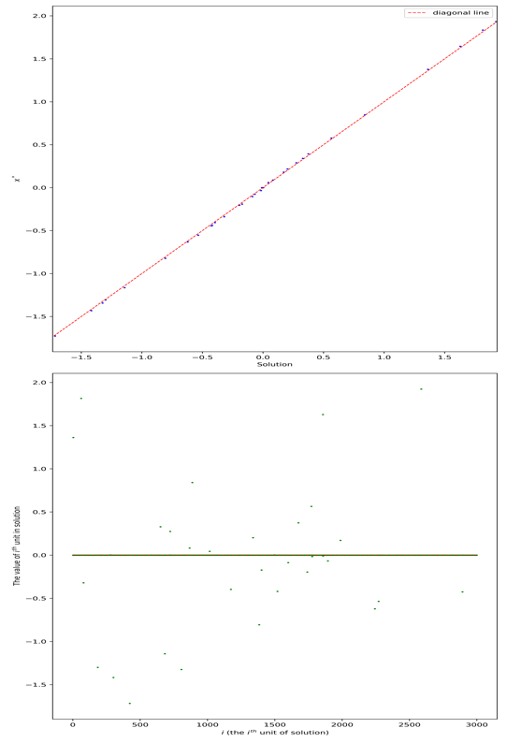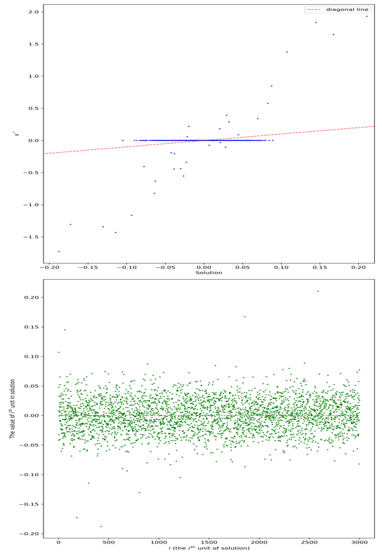(a) AGM on $f_{1}$ (b) AGM on $f_{2}$

**Figure 5 the comparison between solutions and $x^{*}$, and check the sparse of solutions**

As we can see from Figure 4. When we apply AGM to f1, the gradient can converge in 62 times, which is much smaller than that in f2 (2023 times). As we can see from Figure 5(a), When using AGM, f1 is not a good model. This is because the solution is far away from x∗, which means the solution is not what we want. Besides, the solution is not sparse, there are small number of 0 in the solution’s units actually. On the contrary, as we can see from Figure 5(b), when using AGM, f2 is really a good model. The solution is very close to x∗, because they are almost totally on the diagonal line. Besides, the solution is also sparse, there are just small number of units in the solution are not 0, but most units of them are 0, which means the solution is sparse.

(2)IGM

For IGM method, we applied it into f1, f2 and f3. We seperated the experiments into two parts: ”Know Lipschitz constant” and ”Not know Lipschitz constant”.

a): Know Lopschitz constant

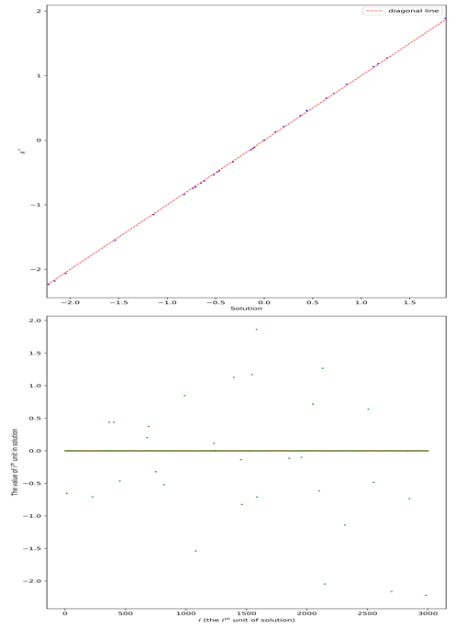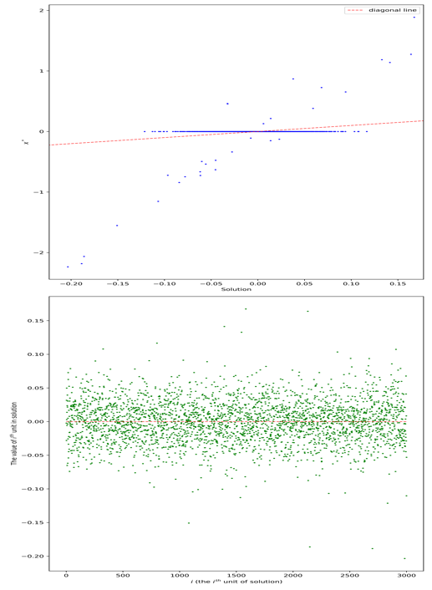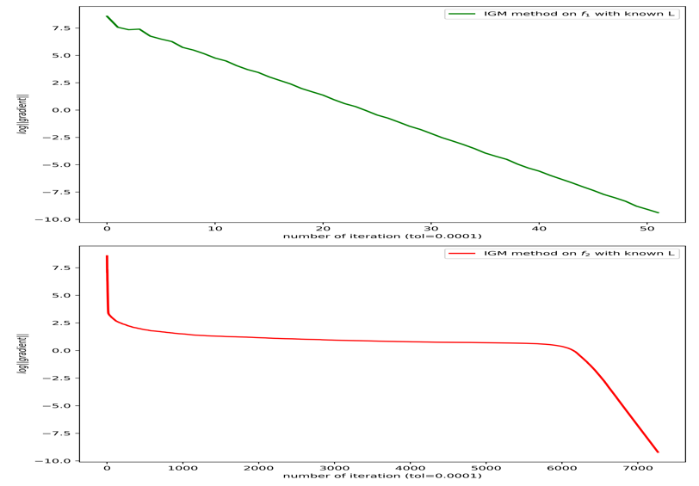**Figure 6 The plot of iteration process by IGM with known L**

**Figure 7 The comparison between solutions and X*, and check the sparse of solutions**

In this part, we applied IGM into f1 and f2, we computed L1 and L2 explicitly. For f1, we choose the parameters as: μ = 1. For f2, we choose the parameters as: μ = 1,δ = ${10}^{-3}$. We select $x^{0}$ = 0 as the initial point and tol= 10 . The performance is measured by comparing ∥∇f(x )∥. The result is showed in Figure 6. Then, we reconstruct solution and compate them with x∗, the result is showed as Figure 7.  
As we can see from Figure 6, when we apply IGM with known L to f1, the gradient can converge in 52 times, which is much smaller than that in f2 (7267 times). And we can see that there is a plateau period in the convergence process of the gradient of f2.  
As we can see from Figure 7(a), When using IGM with known L, f1 is not a good model. This is because the solution is far away from x∗, which means the solution is not what we want. Besides, the solution is not sparse, there are small number of 0 in the solution’s units actually. On the contrary, as we can see from Figure 7(b), when using IGM with known L, f2 is really a good model. The solution is very close to x∗, because they are almost totally on the diagonal line. Besides, the solution is also sparse, there are just small number of units in the solution are not 0, but most units of them are 0, which means the solution is sparse.

• (b): Not know Lipschitz constant In this part, we applied IGM into f1, f2 and f3, we do not compute L1, L2 and L3 explicitly. On the contrary, we treat the Lipschitz constant as unknown, and we use Algorithm 1 (mentioned before) as a variant to do IGM. For f1, we choose the parameters as: μ = 1. For f2, we choose −3 −3 The parametersas: μ=1,δ=10 . Forf3,wechoosetheparametersas: μ=1,δ=10 ,ν= ${10}^{-4}$. We select x = 0 as the initial point and tol= ${10}^{-4}$. The performance is measured by comparing ∥∇f(xk)∥. The result is showed in Figure 8. Then, we reconstruct solution and compate them with x∗, the result is showed as Figure 9.

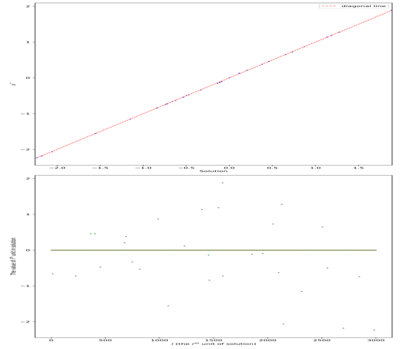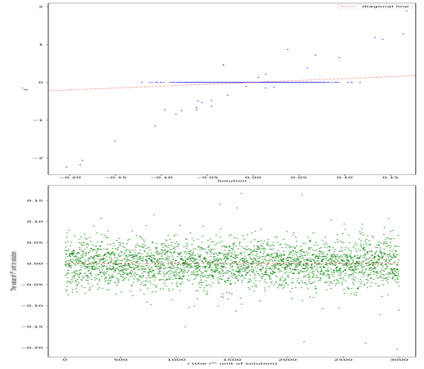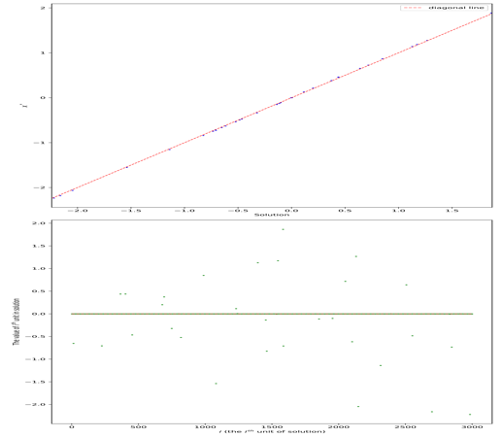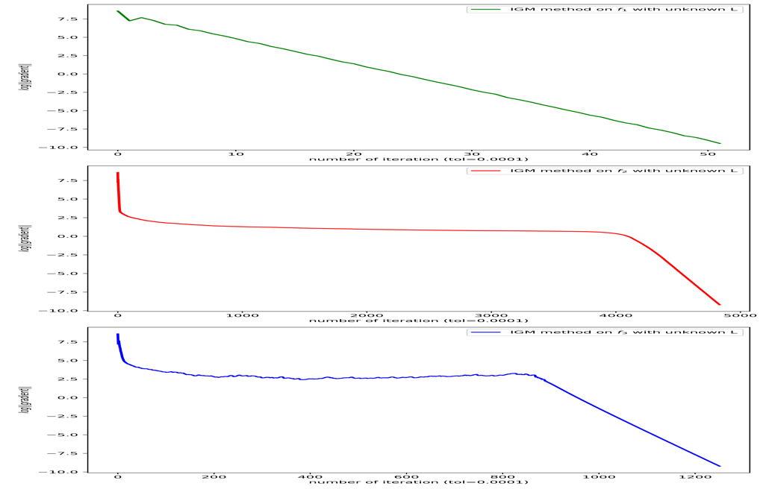 **Figure 8 The plot of iteration process by IGM with unknown L**

**Figure 9 The comparison between solutions and X*, and check the sparse of solutions**

As we can see from Figure 8, when we apply IGM with unknown L, the gradient of f1 can converge in 52 times, the gradient of f2 converges in 4835 times, and the gradient of f3 converges in 1252 times. And we can see that there is a plateau period in the convergence process of the gradient of f2 and the gradient of f3.

As we can see from Figure 9(a), When using IGM with unknown L, f1 is not a good model. This is because the solution is far away from x∗, which means the solution is not what we want. Besides, the solution is not sparse, there are small number of 0 in the solution’s units actually. On the contrary, as we can see from Figure 9(b) and Figure 9(c), when using IGM with unknown L, f2 and f3 are both good models. The solution is very close to x∗, because they are almost totally on the diagonal line. Besides, the solution is also sparse, there are just small number of units in the solution are not 0, but most units of them are 0, which means the solution is sparse.

(3) Summary

Above all, we have applied AGM and IGM (with known L and unknown L) method to solve f1, f2 and f3 models respectively. The iteration times is concluded as Table 3.

|  |  |  |  |  |  |
| --- | --- | --- | --- | --- | --- |
| Method | Model | tolerance | iteration | Time(s) |  |
| AGM | $$f_{1}$$ | $${10}^{-4}$$ | 62 | 0.978 | 4.775 |
| $$f_{2}$$ | $${10}^{-4}$$ | 2023 | 115.113 | 0.085 |
| IGM(know L) | $$f_{1}$$ | $${10}^{-4}$$ | 52 | 0.406 | 5.392 |
| $$f_{2}$$ | $${10}^{-4}$$ | 7276 | 417.809 | 0.086 |
| IGM(not know L) | $$f_{1}$$ | $${10}^{-4}$$ | 52 | 0.488 | 5.392 |
| $$f_{2}$$ | $${10}^{-4}$$ | 4835 | 626.245 | 0.086 |
| $$f_{3}$$ | $${10}^{-4}$$ | 1252 | 149.43 | 0.036 |

As we can see from Table 3, model f3 is the best in these tasks. When and do not compute L explicitly, the iteration times is 1252, which is smaller than model f2. And the solution of model f3 is the most close to x∗, as we can see the value ∥xk − x∗∥ equals 0.036, which is very small.